1. – Investigation

Contents

2.1 Existing System 2

2.11 Investigation 2

2.12 Key Findings 2

Observation 2

Interview 2

Document analysis 3

Questionnaire 3

2.13 Inputs, Processes & Outputs 4

2.14 Stakeholders (Involvement) 7

2.15 Limitations 9

2.2 Research into Existing Solutions 10

Epos Now 10

Southwest Systems 12

Best Features / Facilities 14

2.3 New System 14

2.31 Stakeholders (Requirements) 14

2.32 Specification 15

2.33 Methods to be used 17

2.34 Objectives 17

# 2.1 Existing System

## 2.11 Investigation

|  |  |  |
| --- | --- | --- |
| Method of Investigation | Reason for Use | Evidence Location |
| Observation | To see the current system working and see how it is used  I am going to be observing the main shop in Chorley. I will watch the whole day and see what the staff do on a day to day basis | [Appendix 1](Observation.docx) |
| Interview | To see what the staff think about the current system and any improvements that they want making to it.  I am going to interview the staff at the main shop in Chorley. I will interview Tom, who is an employee; John, who is one of the bosses and Conner, who is an employee |  |
| Document analysis | To see what current documents they are using and how the documents are layed out.  I will be looking at the order sheets from one of the product orders sent to the main store from one of the other shops. | [Appendix 2](Appendix%202%20-%20document%20Analysis.docx) |

## 2.12 Key Findings

### Observation

See [Appendix 1](../../) for full observation.

Overall, the observation showed me that the staff have plenty of time at the start of the day to clock in and that **peak times** are around and after lunch time. As the **day goes on** the staff seem to have **less to do** in the shop. This is as they will have already cleaned the shop and stocked the shelves behind the counter.

* They have plenty of time to use the system that I am making and also a lot of the time the staff are standing around doing nothing.
* The staff have the time that it will take to clock in and out of the system in the morning, at lunch and at the end of the day, which is normally when they have the least to do.

### Interview

Questions:

+follow up

**What features specifically don’t you like about the current system?**

Conner -buttons are too small and sometimes it takes more than one click to hit the button that you want to click

John – the clock in clock out system that is currently in this system just doesn’t work for what I want it to. It wont allow the staff to clock in at the start of the day, then clock out at lunch, clock back in after lunch and then clock back out at the end of the day. The clock in and out system doesn’t round the clock in time to the next hour after being 10 minutes late either.

Tom – I don’t like how the order sheets aren’t consistent. All of the shops should lay out the orders the same which would make is much easier to do, but they don’t. each shop seems

**What features do you specifically like about the current system?**

Conner – I like how the system looks, and the login screen that you click on your name and then type in a pin number to access the system. It is really quick and it works really well, especially when you are in a rush when there is a huge line of customers waiting.

John – I like how it is reliable, as the system barely ever crashes, even though it is really slow. When it does not work, it is always the internet that has stopped it from working.

**What do you find easy to do on the current system?**

Conner – logging into it, doing sales

Tom – logging in, searching for customers.

John – logging in

**What do you find difficult to do on the current system?**

Conner – adding discounts, finding certain products

Tom – searching for a customer

John – clock in and out the way that I want it to be done.

**If you could add one feature to the current system what would it be?**

Conner – I would make it really easy to find all products. I would add a search bar at the top of the screen that you can search for anything in, customers, products etc.

Tom – I would make the buttons in the program bigger so that they are easier to press

John – other than the clock in clock out, I would make it so that the passwords had to be changed more often.

**In your opinion, what could make the shop run more smoothly?**

Conner, Tom – more efficient orders.

John – Orders to be easier to receive so that I don’t have to send orders to the staff. I want the staff to receive them so that I can get on with my work.

**Do you feel like you could be doing more with your time at the shop?**

Conner – yes, we stand around a lot.

Tom – yes, we need to clean more.

John – yes, I look at the cameras and the staff are standing around. I could be working instead of telling the staff to carry on working.

### Document analysis

See [Appendix 2](Appendix%202%20-%20document%20Analysis.docx).

Overall, the two documents show **inconsistencies** amongst the shops, which can cause **confusion**. One is better laid out than the other, as it has **tables** with **relevant columns** for data. Even though **none** of them are in **alphabetical order**. Being in alphabetical order would help as the products would be **easier to scan through and find**.

## Questionnaire

Built on google forms –

How do you find the current system?

1-10

How easy are orders to do?

1-10

Do you enjoy doing orders?

Yes / no + explain

Do you feel like the current system slows you down?

Yes / no + explain

Do you find the current system easy to use?

Yes / no + explain

Does the current system confuse you at all?

Yes / no + explain

How is the security in the current system?

1-10

How often are passwords / pins changed?

Less than every few days?

Less than every few weeks?

Less than every month?

Less than every year?

Less than every 2 years?

Over every 2 years?

Never

## 2.13 Inputs, Processes & Outputs

**Staff File**

Analysis – explanation and example

|  |  |
| --- | --- |
| Inputs | Analysis |
| Name | *Staffs names* |
| Main location | *The location that the staff member is normally at: Atherton, Bootle, Crosby, JK e-cig warehouse main store, Preston, Southport* |
| role | Role can be ADMIN, Cashier, internet orders, Manager, Supervisor |
| Password | *This is a security measure to stop unauthorised people from using the system* |
| Clocking in and out times | *This will be the times that they have clocked in and out during the day, these will be stored in a file* |

|  |  |
| --- | --- |
| Processes | Analysis |
| Add staff | Add a staff member to the system (not hardcoded) |
| Edit staff details | Able to edit existing staff details once saved to the system |
| Change staff roles | Able to change the roles of staff once a role has been established |
| Delete staff | Able to change the staffs password once it has been established |
| Retrieve staff details | Retrieve staff details once it has been saved to the system. |
| Check staff password | Check the password of the staff that has been saved against a password that is entered to try to login to the system |
| Search for staff | Search for a member of staff and show a list of them. |

|  |  |
| --- | --- |
| Outputs | Consideration |
| Generate a list of staff | *Make a table of staff to output to the user* |
| Generate a list of hours that the staff have worked | *This is done currently by calling around the shops and asking who is on the other end whether certain staff were in certain days* |

**Customer File**

|  |  |
| --- | --- |
| Inputs | Analysis |
| Title | *This is the thing that goes infront of peoples names. Eg, Mr, Mrs, Ms, Miss, Dr, Sir, Master, Prof, Rev* |
| Forename | *This is the Persons first name, such as John* |
| Surname | *This is the Persons last name, such as Doe* |
| Date Of Birth | *This is the date that the person that is being entered into the system was born, such as 02/03/1986* |
| Contact Number | *This is the persons primary contact number, such as 07564 653957* |
| Contact Number 2 | *This is the persons secondary contact number, such as 07344 745683* |
| Email Address | *This is the persons main email address, such as thisISATest@gmail.com* |
| Type | *This is the type of customer that is being added to the system. Eg None, Basic, local, Gift Card* |
| Use Expiry Date | *This is to say whether the customer will expire or not, this will be a tick box* |
| Expiry date | *This is the date that the customer will expire from the system, such as 01/01/2019* |
| Card Number | *This is the number on the card that is given to the customer, 01337299332* |
| Notes | *These are any notes that can be made about the customer, this can include anything from* |
| Sign up location | *Shop locations, such as atherton* |
| Address ( new entity) | *Add name, Ln 1, Ln 2, Town, County Postcode* |

|  |  |
| --- | --- |
| Processes | Analysis |
| Add a customer | *Add a customer to the system* |
| Edit customer details | *Edit the customers information such as email or contact number. This allows their data to be kept up to date* |
| Delete a customer | *Remove a customer from the system, this allows the customer database to be shortened if a customer wants to remove an account* |
| Search for a customer | *Allows searching of a customer from a database through the system* |
| Sort customer file | *This allows the file containing the customers to be sorted so that the names are in alphabetical order when they are stored.* |
| Add address for customer | *This allows addresses to be saved as a separate entity. This allows the easy addition of multiple people from the same address* |

|  |  |
| --- | --- |
| Outputs | Consideration |
| Return table of customers searched(electronic) | *This allows the data from a search to be shown in an easy to see table that shows the details of the customers that are returned from the search.* |
| Save customers details to file.(electronic) | *This allows the customer details to be saved so that the system can access the data after a restart. The data is read back into the file once the program restart.* |

Stock File

|  |  |
| --- | --- |
| Inputs | Analysis |
| Name | *This is the name of the stock that is being entered into the system, such as Jks Strawberry 8Mg* |
| Description | *This gives a general overview of the product, such as flavours or what coil it uses and how to use it* |
| Cost Price | *This is how much it will cost for a customer to buy the product, such as £18.50* |
| Category | *This is the category that the product is in, such as e-Liquids or Coils* |
| Brand | *This is the brand that the product is, such as Nautilis* |
| Supplier | *This is to tell the bosses where they bought the product from, and so if they need to order more they know where to order it from.* |
| Product order code | *This is to use with the supplier when ordering the product, such as 22114234* |
| Popup note | *This is a note that will popup when the staff sell this particular product* |
| Amount of stock | *This tells the boss how much stock is supposedly left in the shop* |

|  |  |
| --- | --- |
| Processes | Analysis |
| * *Add, Edit Search, Sort, Filter, Calculate, Store, Retrieve etc.* | *(What do they do with the data?)* |
| Add a product | *This allows a product to be added to the system.* |
| Add amount of product | *This allows the amount of product to be edited so that the amounts are correct.* |
| Edit product details | *Allows any of the details of the products to be changed, this allows the data about the products to be correct and up to date* |
| Search through stock | *This allows stock to be searched for and returned* |
| Store amount of stock | *This allows the amount of each piece of stock to be stored and so the stock counts can be kept up to date* |
| Retrieve stock lists from a file | *This allows the program to retain data even when the power is switched off. The data can be read back into the file* |

|  |  |
| --- | --- |
| Outputs | Consideration |
| Return table of Products searched | *This allows the results of the search to be shown as an easy to read table of results* |
| Save Products details to file. | *This allows all of the data about the products to be saved* |
|  |  |

## 2.14 Stakeholders (Involvement)

|  |  |
| --- | --- |
| Bosses | Description |
| Image result for stickman stick woman | * Bosses manage the shops and have to approve the sales that the shop does at certain times. * The bosses wont use the system that much, they will only really use it to get information about orders and also getting information about stock that they have in the shop. |

|  |  |
| --- | --- |
| Managers | Description |
| Image result for stickman stick woman Image result for stickman stick woman | * Each shop has a manager, and these managers keep a closer eye on the shops for the bosses. The managers function as normal shop staff but have slightly more authority than the normal staff * I am going to have to add a new access level for managers * Managers will use the system quite regularly and will need to be able to check how things are running on the system. * The managers use the system about the same amount as the other employees as they do the same type of work. |

|  |  |
| --- | --- |
| Employees | Description |
| Image result for group stick people | * Employees use the current system very regularly. They have their own logins and pins to access the system. * They directly access the system and are influenced by the speed of the system and any problems that may be caused by the system |

## 2.15 Limitations

|  |  |
| --- | --- |
| Limitation | Consideration |
| *The current system cannot be used for the clock in clock out the way that the boss wants to do it.* | *The current system does not allow the staff to clock in more than once every day. The boss wants it so that the staff clocks in at the start of the day, clocks out at lunch, clocks back in after their lunch and then finally clock back out at the end of the day. The boss wants a threshold of how late they can clock out and in before it rounds their hours down.* |
| *If you haven’t used the system before, it is very hard to figure out where certain things are kept.* | *The current system is really hard to figure out where certain things are kept. As some products could be in two different categories, and it is only listed in one. Sometimes the only way to efficiently find the product is to search for it.* |
| *The current system has outdated passwords for staff.* | *The passcodes never change and most staff know each others passcodes. This is not good as the normal staff know the managers passcodes. This means that the staff can do things that they shouldn’t be able to do, such as authorise discounts to products, which only managers should be able to do.*  *I know for a fact that on the particular till that I used, one of the bosses didn’t actually have a password for the system. This is not very secure as anyone can click login and they can access the inner workings of the system. This is not very safe, as data can be changed and malicious activity could easily take place* |
| *Products that require certain specific products to work are not linked together.* | *This makes it really hard if you don’t know which coil for example goes with which E-Cigarette to sell the customer the correct one. I worked there over summer and it was really hard to get a grasp of which coils can go with which E-Cigarettes and which liquids can be used with each coil. The system has no way to link these other than the product description that nobody knows how to find and read. The product description is not easily accessible at all.* |

# 2.2 Research into Existing Solutions

I have searched for stock control systems

* Epos Now
* Southwest Systems

## Epos Now

What is Epos Now? Epos now is a full till, stock control, clock in clock out and sales reporting software and hardware bundle.

Epos is one of the fastest growing, most exciting multi-award winning businesses in the uk. Epos was launched in 2011, Epos now was founded on a belief that all businesses and entrepreneurs should be able to leverage the power of both cloud computing and modern technology to power their businesses.

Epos has over 90 Integrations, which is the highest number in industry. They also have a 150% year on year growth, it is the UK`s largest growing tech company. Epos is trusted by over 30,000 businesses such as universal studios, ebuyer.com and Best Western.

Epos has over £5,000,000,000+ in transactions in 103 countries and is also number one rated on TrustPilot

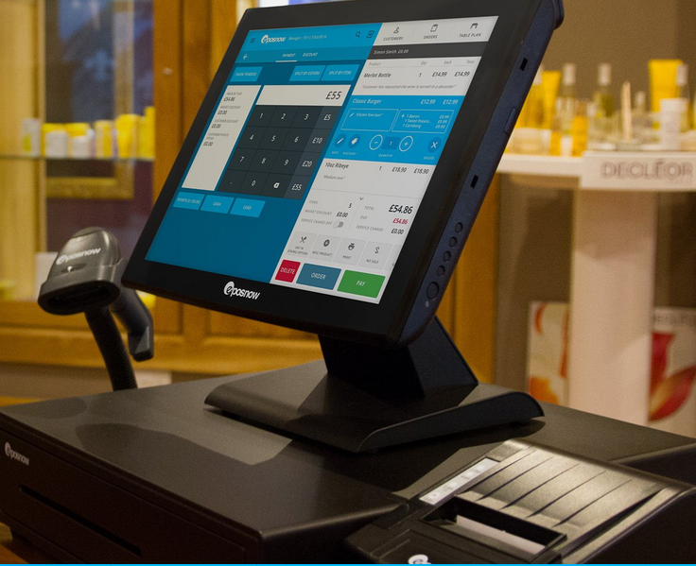Epos now is easy to set up and use “within minutes” it works with all POS hardware, which means that is has an excellent compatibility with whatever POS hardware to be used. This means that it can be used my almost any pre-installed POS system.

Epos now has different aspects that are included. One of these is reporting, which is really interesting. Epos connects all of the tills together and will tell the user on the website how sales are going. Epos will go as far as to say which shop is doing the best sales this week.

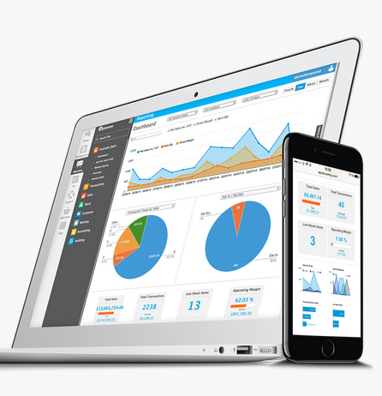Reporting

The reporting has a customisable dashboard, which enables the user to tailor it to their liking and makes them not stuck with a certain layout that they don’t like.

The reporting is all online, so you can check it on your phone and it also allows the user to get an instant overview of the business across all locations. The reporting dashboard can give real-time product, sales and employee performance reports from anywhere at any time.

Back Office

This is another tab on the till, the back office allows any and all aspects of the program to be changed or added. The back office is how you add customers, products and much more. The back office allows access to the entire management system from any device, from anywhere in the world allowing the user to have complete visibility and control of the business, the shops inventory and the staff.

The back office allows the easy addition of products and also easy editing of existing products. The back office also allows the user to start a “spontaneous promotion” from the web-based back office from anywhere.

Security

The software allows the use of different authorisation levels for each of the staff in the company, to enable them to control discount levels and also restrict who can offer refunds of products or void sales entirely. The boss is able to monitor discount levels by employee in the back office. The discount levels allow the staff to only be able to discount the stock so much, so a normal employee is not allowed to give a discount above 25% without a sale or a manager. This stops normal employees from giving themselves a big discount on the products that are sold in the shop.

All of these features protect the company from employee fraud. This prevents unauthorised access to the system through pin number or staff swipe cards and keeping sensitive information like profit margins hidden from the customers or anyone else who might want to see it.

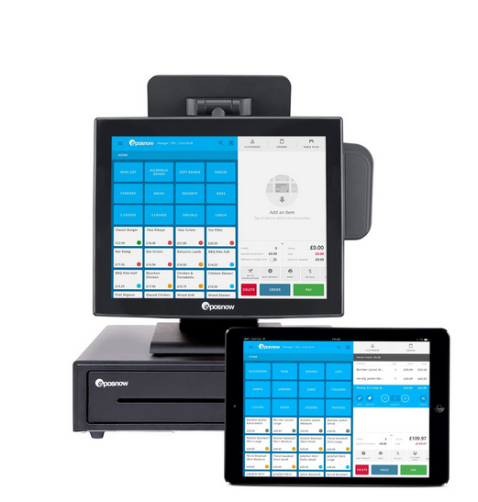Inventory

The software allows the boss to have a complete awareness of the inventory levels, which eliminates many of the unnecessary stock takes. Epos allows the company to monitor its wastage and shrinkage, whilst ensuring you always have your best- selling products in stock and ready to sell.

The program can also streamline the stock ordering process by automatically raising purchase orders, and easily managing inter-location stock transfer. This lets shops in the business easily add and remove amounts of stock between the stores on the system and not have to go into the settings and add the numbers of stock in manually.

Customers

Epos now allows you to add the customers quickly as they make purchases, this allows the user to invoice them, give them credit and collect marketing information such as email addresses and phone numbers from them.

All of these will only enhance the running of the business. Epos also has a loyalty module, which provides customers with branded loyalty cards, this allows the customers to receive points for their purchases and receive preferential pricing. This encourages the customer to buy more from the shop and so they get more money off the products that they really want and use. All of this encourages repeat business and drives brand loyalty.

Staff

Epos allows staff to clock in and clock out through the till, which removes the need for a separate system to clock in and clock out with. Then the back office will automatically generate how many hours they have worked and also calculate their pay.

Epos also has integrated extensive employee reporting, which allows the boss to recognise their best performing staff, it will also highlight those that are under performing. This will help the boss to see which staff are the most successful at upselling. And also who is the best at selling each product, this can help the boss to identify gaps in training.

Epos also has integrated payments, it will accept credit and debit cards, with their extensive global merchant partners. It claims to be the worlds easiest POS system, and that Staff can be fully operational in just 15 minutes.

Epos also works with any device, which means that you can use the system with an iPad, phone, laptop, or the till.

There is Access rights and permissions in the system, this allows restriction to any till function, such as discounts or refunds, so that staff that are high enough ranking or not trained enough cannot give a refund to a customer and will need to get a higher ranking member of staff to do it. The till also enables clocking in and clocking out right from the till front.

The system allows the user to create their own custom promotions, such as but not limited to meal deals, happy hours, buy 1 get one free. Epos also allows you to track the promotions easily too.

Epos also gives you access to a powerful booking system, which can be accessed anywhere. This is perfect for managing appointments or an online staff rota. The system also allows you to print customised receipts with images and special offers, it also allows you to track historic transactions and email receipts for returning customers.

Epos now has dedicated versions for both retail and hospitality, these have different features that would be better suited for the different environments. For stock management on Retail to split bills on the hospitality versions.

## Southwest Systems

What is Southwest Systems? Southwest systems are the leading cloud EPOS till system distributors and software suppliers for the whole of the UK and worldwide.

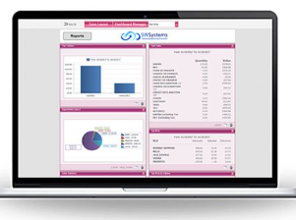Southwest systems` award winning SWS VR RPOS Till systems have superior performance and functionality for all types of shop businesses. It has brilliantly crafted front end till software with hundreds of easy to use features as well as detailed electronic reporting on their high-tech cloud back office software. The system includes a well-built heavy-duty system and software by Casio.

The SWSystems EPOS till systems and cloud software is the complete enterprise solution for all business types from a busy single site to multi-site franchises and chains. Their leading EPOS tills use reliable cloud, web based technology to provide real-time date ranged electronic reporting to head office, as well as the ability to customise the products and pricing from any location and from any device.

Front end EPOS till software

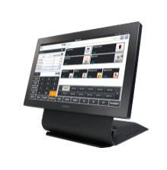Their smart, EPOS till software has been methodically designed and crafted with over 7 years if development. This means that their software is not only great to look at, but also highly functional with hundreds of features, functions and reports. Management and staff security comes as standard as well as detailed financial reporting on the cloud back-office software. Functionality on the front-end EPOS till system includes scancode search function, item search function, reduced price options, discounts by amount, percentage, total, item and complimentary, vouchers facility, 2 for 1 mix and match, cheapest free and many more

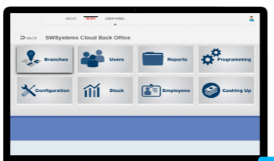Cloud based back office

SWSystems cloud back office software is a unique web browser back office package that allows business owners, management, head office admin and accountants to access real-time and date ranged electronic rich report data from any location and from any PC, tablet or smartphone. More and more businesses enjoy the huge benefits of our superior cloud bases back office software as this allows store owners and accounts departments to easily view reports instantly as well as export sales and other reports to PDF, excel, CSV. Furthermore, all price changes and item creation can be done seamlessly from the cloud back office which is both simple and quick to do. For retail and hospitality sites their cloud stock control software allows store owners and management to view real-time stock levels in each branch as well as carry out purchase ordering with suppliers, add wastage stock taking and unit conversions can all be easily setup on the cloud back office software. Other great features our software offers include end of day terminal reconciliation, branch reporting, electronic journal viewer to monitor staff voids and discounts, item sales, item sales by staff, hourly sales report, hourly sales report by staff, item sales profit report, top 50 best sellers, real time stock level report with cloud stock control software, discount totals, time and attendance, hours worked, cloud customer points loyalty using loyalty cards, cloud mobile app loyalty for balances, statements and card top ups, and many more.

Their expert engineers will fully set up the system for you, this includes the cloud store and front end EPOS till system which will be specifically tailored to the business specifications. Any amendments to the system are done at no extra cost.

Cloud software options can be added or removed at any point in time to suit the business requirement.

The system includes **Integrated card** or **standalone** card payments, SWSystems are partnered with the latest car companies offering the **best rates** for integrated and non-integrated Ingenico credit card terminals.

The system also includes **fast retail scanning**, the **barcode scanners** are ideal for busy retail stores who require the ability to scan barcodes quickly. They supply both 2D and 1D multi directional scanners as well as **heavy duty**, **low cost hand scanners**. And they also cater for businesses that need to mix and match the two

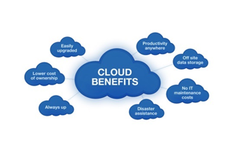SWSystems include a **real-time cloud stock control** including an advanced cloud stock control software. Which allows the user to monitor **real-time stock levels** at each branch in a split second from the **cloud back office.** They also cater for **Wastage, branch stock takes, website stock integration, and integrated label printing for stock without a barcode** and much more

The system allows **staff contests**, these help increase average spend, upsell, improve customer service or boost morale. These simple competitions will help to convert staff from labour costs to marketing tools by motivating them, increasing employee retention and improving the customer experience.

The system has Points, Discounted loyalty and top ups. These are for customers, and the points can be added at any point to their range of SWS VR EPOS till systems, and they can offer total amount discount loyalty. In other words for every £1 customers spend it is worth 5 points, which could be worth 1p.

## Best Features / Facilities

|  |  |
| --- | --- |
| Feature/Facility to include | Source |
| *Search Button* | *Epos Now* |
| *Access levels that allow restriction to pretty much everything.* | *Epos now* |
| *A back office tab to add customers, stock and manage everything* | *Epos now* |
| *Reporting real-time results about the system itself and the business* | *Epos now, Southwest Systems* |
| *Staff competitions to improve morale and improve up sales and average spend.* | *Southwest Systems* |

# 2.3 New System

## 2.31 Stakeholders (Requirements)

|  |  |
| --- | --- |
| Boss | Description |
| Image result for stickman stick woman | * The boss needs to be able to easily check up on the clock in and clock out times and see who is late * The boss needs to be able to easily check up on how much stock there is in the shop. * The new system will enable the boss to check up on the shop more easily than he currently is |

|  |  |
| --- | --- |
| Managers | Description |
| Image result for stickman stick woman Image result for stickman stick woman | * Managers currently have the same access privileges as the staff that are lower than them, meaning that they cannot do what they need to do to manage the shop. * The managers will be able to use the system to check up on how the stock is and then they can order more if they need it. |

|  |  |
| --- | --- |
| Employees | Description |
| Image result for group stick people | * The normal staff need to have less access to parts of the system than that of managers and the bosses. This will enable them to not cause as many issues accidentally with the system as they are less experienced with the system. * The normal staff wont be able to add discounts past a certain percent and will only be able to add discounts that are approved by a manager and the managers pin is entered. * The staff wont be able to accept returns if a manager is not present, this will stop the normal staff from making a mistake by accepting a return that is past its warranty or its warranty is void. |

## 2.32 Specification

The new system is aimed to improve upon the old one. It will do this by providing a better way to log the hours that members of staff have worked other than asking which days staff are in work and which days they are off.

The new system will also give a better way to send off orders to the main shop, as currently it is being done in Microsoft word and it is not very well laid out. And the products weren’t even listed in alphabetical order, which is unacceptable, and this makes it harder to scan through the product list and find a product and figure out whether the product is to be sent to the other shop or not.

I am going to use java to write this program, which is an object-oriented approach, this will be to my advantage as within the program I am going to need to use entities such as Staff, customers, products and others. The objects will allow me to easily manage the data that will be input into the system. I am going to use arrays of objects to store the data about the attributes of the program such as the staff, customers and the products.

**Interface**

To create the GUI I am going to use the java swing library, this will allow a simple approach to a GUI that can look professional.

The new system will look visually appealing but not be too cluttered or distracting. It will have a search bar at the top that will recognise which screen you are currently on and will **search accordingly**.

The GUI will be **durable** and will be **easy to learn**. Simple and complex tasks will be easy to complete.

The interface will **not** be **cluttered or busy**. If the interface is really cluttered, then the user could get **distracted confused** or lost with it and this will make it more difficult to complete tasks with the new system.

The interface will have **buttons** that are **easy to click**, this will eliminate the annoying nature of buttons that are hard to click that require a lot of taps on a touch screen to actually hit the button.

The buttons on the GUI are going to be **well spaced** and this will make it so that it is harder to accidentally hit the wrong button while trying to hit another button.

**Functions**

**Searching** through **staff** database and returning a table should take **no longer than a second.**

Within java I am going to make many **methods** and **functions** that will be able to do repetitive tasks easily.

I am going to use **physical pointers** in the program to get around javas **arrays** **static** **nature**. The array size **cannot** be changed, so I am going to set the arrays to be a **large size** and then use location pointers to show where the array **data stops**.

The search algorithms that I am going to use are **binary** and **linear** searches, as these are relatively **easy to build** and **work quite well**.

The sort algorithms that I am going to use are **bubble sort** and **insertion sorts**, this is because they are **relatively easy to create** and are **very effective** at sorting.

**Searching** through the **customer** database should take no longer than the amount of **customers/20 + 1** second, so for **100** is should take no longer than **6 seconds** to return a result table.

The system will allow the staff to **clock in and clock out** at the **relevant times** and also round up or down to the **nearest hour** when necessary (late into work etc).

Order sheets can be generated in **tables** that are **sorted** via group and then within the group by alphabetical order (from a -> z).

The system will have **access levels** to control everything from discounts to returns. This will make it so that a staff member that does not have the authority to give out a discount or to give a refund for a purchase can`t do it. This will **stop the staff from incorrectly giving a refund** where the product was out of warranty or a refund wasn’t allowed or giving out a discount **without a manager’s approval**.

**Performance**

I want the program to have a **fast response time**, this will stop the staff from getting annoyed with the system and not using it.

If the system is running on a slower system it will not run as quickly as it would on a quicker system, but it should still be functional and should still work respectively and to a good standard.

The system should be **reliable** and **not crash** constantly, this will make it so that work can be done easily on the system without the thought that it might crash, and you might have to redo the task that you were doing before the crash.

## 2.33 Methods to be used

|  |  |
| --- | --- |
| Method | Technical Justification |
| *Clear table* | *This will clear any table that is in the GUI. This will make it really easy to refresh the tables in java.* |
| *Arrays of objects, such as Staff, Customer, Product* | *This will make it really easy to store information about the objects, for example about a person, if I was to use a 2D array I would need to add so many rows and columns to it, but with an object array I can just easily add attributes to the object and then save the object in an array of objects.* |
| *I will add presence checks* | *many of the attributes that can be entered into the program need to be present in order for the program to work correctly, so I am going to add presence checks on user inputs to make sure that the program has data that it requires in order to run correctly.* |
| *Format checks* | *This will be added to many fields, such as dates, to make sure that it is in the correct format so that the program can process the data.* |
| *Search pointers* | *This is so that when I search for attributes, the location of where the attribute was found can be stored, so that it can be used in later processes.* |
| *Next object location pointers* | *This means that when searching or iterating, the whole array isn’t iterated through, as this would just waste time. Instead the program will only iterate through the filled part of the array.* |
| *Bubble sort* | *It is efficient, and it works both ascending and descending.* |
| *Linear search / binary search* | *I will use these as they are relatively easy to implement and write. Also I am not inputting more than 500 different objects of the same type, so timing wont really be an issue.* |
| *I will use data types such as String, Integers, Booleans, characters and doubles* | *These will mean that I can store the data that I need to store effectively using the correct data types for the situation* |

## 2.34 Objectives

|  |
| --- |
| **Objectives:**   * A specific list of tasks needed to accomplish the goals of the project * Emphasize how aims are to be accomplished * Must be highly focused and feasible * Address the more immediate project outcomes * Must be sensible and precisely described * Should read as an 'individual' statement to convey your intentions |

|  |  |  |  |
| --- | --- | --- | --- |
| # | Objective | Success Criteria | Required Performance |
| 1 | Add Staff | Allow successful addition of staff | Add staff to the program to be used after add staff window closes. |
| 2 | Edit Staff details | Allow staffs info to be edited and changed |  |
| 3 | Delete Staff | Allow staff to be removed from the system | Should have validation window to confirm |
| 4 | View All Staff | Allow a list of staff to be shown | Should take no more than 5 seconds |
| 5 | Save Staff to file | All staffs details will be encrypted and stored to file each time a change is made | Should take no more than 5 seconds |
| 6 | Retrieve Staff from file | Staffs data is able to be decrypted from the file and stored in an array | Should take no more than 5 seconds |
| 7 | Search through Staff | Be able to return a table of results | Search less than 2 seconds for 20 staff |
| 8 | Store the amount of hours staff work | Create / update the store of staff hours |  |
| 9 | Display staff names | Be able to show a list of staff names and details |  |
| 10 | Display staff hours worked per week | show on screen the amount of hours that staff have worked |  |
| 11 | Print staff hours worked per week | Allow printing of staff info ( staff list) |  |
| 12 | Store securely staff logins for the system | Encrypt and decrypt data easily at certain points of the program |  |
| 13 | Encrypt passwords | To store the data securely to help prevent changes being made when the staff don’t have the access rights to be able to do so |  |
| 14 | Decrypt passwords before used | Successfully and accurately decrypt passwords |  |
| 15 | Allow different user access rights | allows different access to the program depending upon your role |  |
| 16 | Filter by Name | Allows the data to be sorted and showed in a table |  |
| 17 | Filter by hours worked | Allows the data to be sorted and showed in a table |  |
| 18 | Sort by Name | Data is sorted by name Ascending or Descending and then stored permanently that way |  |
| 19 | Allow different views of data | Views of data change depending upon role of staff that is logged in |  |
| 20 | Backup staff details | Save the staff details in a file that is encrypted and also is stored away from the program |  |
| 21 | Access Level (view staff info) - Admin | Allow only admins to access certain sets of data |  |
| 22 | Access Level (view staff names) - normal | Allow any staff to view certain sets of data |  |
| 23 | Access Level (change staff info) - Admin | Allow only Admins to change certain sets of data |  |
| 24 | Reject incorrect dates – (eg. 31st feb) | If the date is wrong then the program shouldn’t accept it |  |
| 25 | Separate views for different access levels – normal only view names etc  Admin can view all and edit | Allow users different views of data, depending upon what role they are. |  |
| # | Objective | Success Criteria | Required Performance |
| 26 | Add Customer | Allows customers to be added to the program | Instantly added and be able to be used |
| 27 | Edit Customer Details | Allows the data stored in the program to be edited with the correct access rights |  |
| 28 | Delete Customers | Allows customers to be deletes with the correct access rights |  |
| 29 | View all Customer | Allows a scrollable list of customers to be shown on the screen |  |
| 30 | Encrypt sensitive information | Sensitive info is saved only when it is encrypted and is decrypted just before it is used | Encryption takes no more than 1 second per 5 items |
| 31 | Decrypt Encrypted information | Sensitive info can be decrypted before it is used | Decryption takes no more than 1 second per 5 items |
| 32 | Sort customers | List of customers can be sorted by name and saved permanently to file / array | Should take no more than 5 seconds |
| 33 | Search customers | Allows the list of customers to be searched through and searched by name etc | Search should take no more than 5 seconds |
| 34 | Store complaints | Able to store the complaints of the customers and create a log of it |  |
| 35 | Store returns | Store the returns in a file and be able to retrieve it |  |
| 36 | Store customers securely | Encrypt the data stored on customers and save it to a file |  |
| 37 | Backup customers details | Able to store customers data in a separate location to the program |  |
| 38 | Output list of customers | Print or show on screen a list of customers and their data, depending upon what is selected ( also based on access level) |  |
| 39 | Display lists of customers | Show on screen a list of customers in a table on the screen – data is dependent on access level of the user |  |
| 40 | Search by name | Search for a customer by their first name | Return a result within 3 seconds |
| 41 | Search by Last Name | Search for a customer by their last name | Return a result within 3 seconds |
| 42 | Access Level - normal | Allow viewing and editing of data with normal access level. |  |
| 43 | Reject fake info – dates that don’t exist (eg 30th Feb) | Don’t allow data that is of wrong format or is clearly incorrect be accepted into the database | Be able to identify dates that don’t exist within the program |
| # | Objective | Success Criteria | Required Performance |
| 44 | Add return | Returns can be added to the program | Data added should be able to be accessed right away |
| 45 | Edit return | Able to have data edited |  |
| 46 | Delete return | Data should be able to be deleted |  |
| 47 | Encrypt return data | Data should be stored securely | Should happen within 2 seconds |
| 48 | Store returns | Saved to a file |  |
| 49 | Read returns from file | Get the returns from the file and read into the program |  |
| 50 | Decrypt returns while reading into system | Able to decrypt before using data |  |
| 51 | View all returns | Show all returns on screen | Retrieve within 2 seconds |
| 52 | Search by product | Search products |  |
| 53 | Print Return list | Print off list of returns |  |
| 54 | Display all returns | Show all returns |  |
| 55 | Search by return date | Search the list of returns by date and return |  |
| 56 | Sort by product | Sort the list by product |  |
| 57 | Sort by date of return | Sort the list by date of return |  |
| 58 | Access level - normal |  |  |
| 59 | Output return info | Show the info of the returns on the screen |  |
| 60 | Generate return ID | Make a unique return id |  |
| 61 | Reject return that is out of warranty (unless admin override) | Not allow products out of warrenty to be returned |  |
| # | Objective | Success Criteria | Required Performance |
| 62 | Add clock times | Add clock times to the system |  |
| 63 | Edit clock times | Admin only edit clock times |  |
| 64 | Delete clock times | Delete the clock times from the list ( admin only) |  |
| 65 | Encrypt clock data data | Encrypt data whenever it isn’t used |  |
| 66 | Store clock data | Store the encrypted data |  |
| 67 | Read clock data from file | Read the clock data from the file |  |
| 68 | Decrypt clock data while reading into system | Decrypt the clock data before using it |  |
| 69 | Calculate hours worked | Calculate the total hours worked per week for each employee |  |
| 70 | Access Level - Admin | Only admins can access this data |  |
| 71 | Display hours worked | Show total hours worked |  |
| 72 | Interface easy to understand / use | The interface will be easy to use |  |
| 72 | Check that staff have clocked in before clocking out | Wont allow clock out before clock in |  |
| 74 | Reject clock out without clock in | Wont allow clock out without clock in |  |
| 75 | Reject clock in after 5:00PM | Wont allow clock in after 5:00PM |  |